
Green University of Bangladesh
Department of Computer Science and Engineering (CSE)
Faculty of Sciences and Engineering
Semester: (Spring, Year: 2026), B.Sc. in CSE (Day)

Lab Report NO: 03
Course Title: AI Lab
Course Code: CSE 316
Section: 232-D5

Lab Experiment Name: Implementation of IDDFS and A* Search Algorithm

Student Details

Name |  | ID
1. | Modabbir Mohammad Mansur | 232002154

Lab Date : 17/03/2026
Submission Date : 30/03/2026
Course Teacher’s Name : Babe Sultana

Lab Report Status
Marks: ………………………………… Signature:.....................
Comments:.............................................. Date:..............................

1. INTRODUCTION
Search algorithms are an important part of Artificial Intelligence for solving graph-based problems. In this lab, two search techniques, Iterative Deepening Depth First Search (IDDFS) and A* Search, are implemented.
IDDFS is used to traverse a graph created from user input and find a path from a source node to a goal node by increasing the depth step by step. A* Search, on the other hand, is an informed algorithm that finds the optimal path using both actual cost and heuristic values. It also shows the priority queue at each step to explain how nodes are selected.
2. OBJECTIVES/AIM
- To implement graph traversal using IDDFS
- To determine a path from a source node to a destination node using IDDFS
- To implement the A* search algorithm
- To understand how heuristic values influence search performance
3. PROCEDURE
Steps for IDDFS:
- Initialize the depth level at 0
- Perform Depth Limited Search (DLS)
- If the goal node is reached, terminate the process
- Otherwise, increase the depth limit
- Repeat the process until the goal is found or the maximum depth is reached
Steps for IDDFS Path finding:
- Maintain a path list to store the current traversal
- At each step, check if the current node is the goal
- If found, return the path from source to goal
- Use backtracking (remove nodes from path if not leading to goal)
- Continue increasing depth until the path is discovered
Steps for A* search:
- Create a priority queue to store nodes
- Insert the starting node with its initial cost
- Select the node with the lowest evaluation value (f = g + h)
- Expand its neighboring nodes and update their costs
- Continue the process until the goal node is reached
- Display the queue contents at each iteration

4. IMPLEMENTATION:
Code:
P-1:Write a program to perform IDDFS traversal on a dynamic graph input from the user.
def dls(graph, node, depth, visited):
if depth == 0:
print(node, end=" ")
return

visited.add(node)

for neighbor in graph[node]:
if neighbor not in visited:
dls(graph, neighbor, depth - 1, visited)

def iddfs(graph, start, max_depth):
for depth in range(max_depth + 1):
print("\nDepth =", depth, ":", end=" ")
visited = set()
dls(graph, start, depth, visited)

# INPUT
graph = {}
n = int(input("Enter number of nodes: "))

for i in range(n):
node = input("Enter node name: ")
neighbors = input("Enter neighbors (space separated): ").split()
graph[node] = neighbors

start = input("Enter start node: ")
max_depth = int(input("Enter max depth: "))

iddfs(graph, start, max_depth)

P-2: Write a program to find the path from source to destination using IDDFS.
def dls_path(graph, node, goal, depth, path):
if depth == 0 and node == goal:
return path

if depth > 0:
for neighbor in graph[node]:
if neighbor not in path:
new_path = dls_path(graph, neighbor, goal, depth - 1, path + [neighbor])
if new_path:
return new_path
return None

def iddfs_path(graph, start, goal, max_depth):
for depth in range(max_depth + 1):
path = dls_path(graph, start, goal, depth, [start])
if path:
return path
return None

# INPUT
graph = {}
n = int(input("Enter number of nodes: "))

for i in range(n):
node = input("Enter node name: ")
neighbors = input("Enter neighbors (space separated): ").split()
graph[node] = neighbors

start = input("Enter start node: ")
goal = input("Enter goal node: ")
max_depth = int(input("Enter max depth: "))

result = iddfs_path(graph, start, goal, max_depth)

if result:
print("Path found:", result)
else:
print("No path found")

P-3: Write a program to perform the A* Algorithm on the following figure. Explicitly Print the queue at each step.
import heapq

def a_star_search(graph, h, start, goal):
open_list = []
heapq.heappush(open_list, (h[start], start, [start], 0))

explored = set()

while open_list:

print("\nOpen List State:")
for state in open_list:
print(state)

f_cost, node, path, g_cost = heapq.heappop(open_list)

if node == goal:
print("\nGoal reached!")
print("Route:", " -> ".join(path))
print("Total cost:", g_cost)
return

if node in explored:
continue

explored.add(node)

for next_node, edge_cost in graph[node]:

if next_node not in explored:
new_g = g_cost + edge_cost
new_f = new_g + h[next_node]

new_path = path + [next_node]

heapq.heappush(
open_list,
(new_f, next_node, new_path, new_g)
)

print("No valid path found.")

graph = {
'A': [('B', 1), ('C', 3)],
'B': [('D', 3), ('E', 1)],
'C': [('F', 5)],
'D': [],
'E': [('F', 2)],
'F': []
}

heuristic = {
'A': 6,
'B': 4,
'C': 5,
'D': 2,
'E': 1,
'F': 0
}

a_star_search(graph, heuristic, 'A', 'F')

5. OUTPUTS:
P-1:
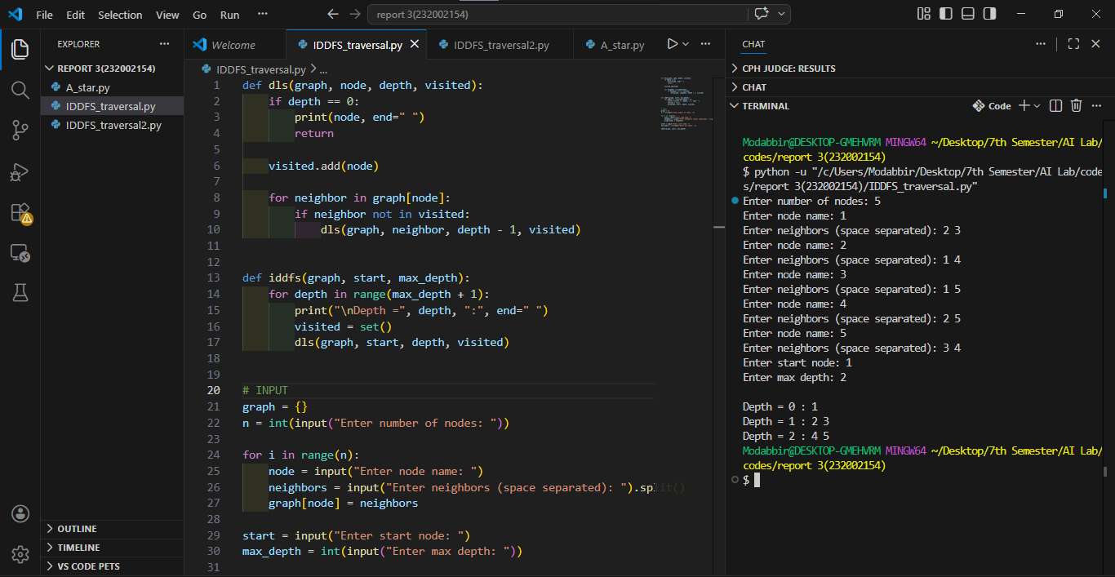

P-2:
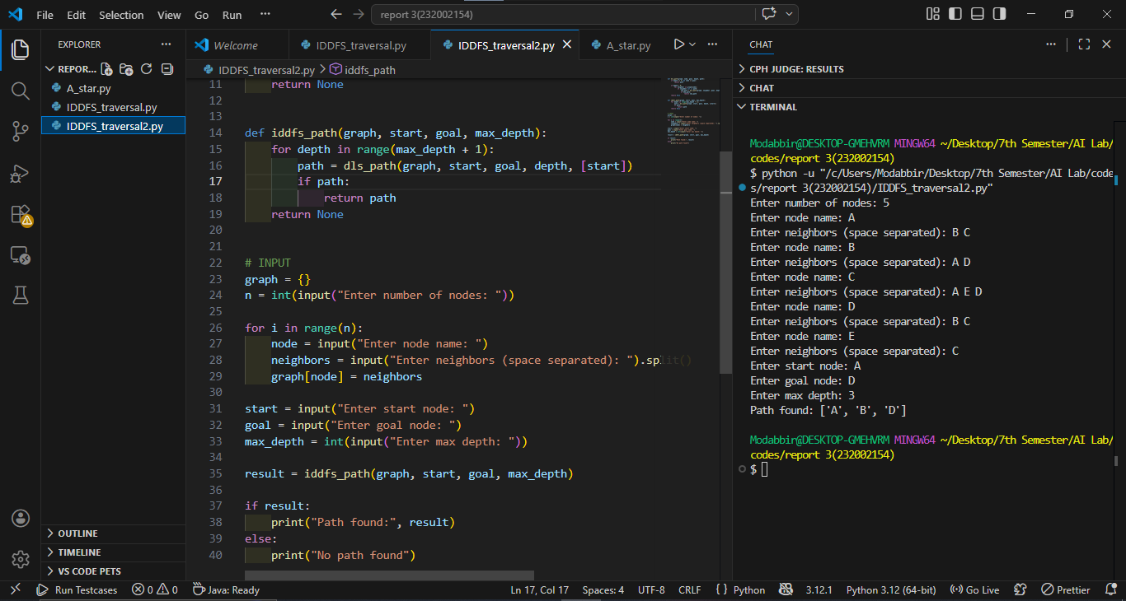
P-3:
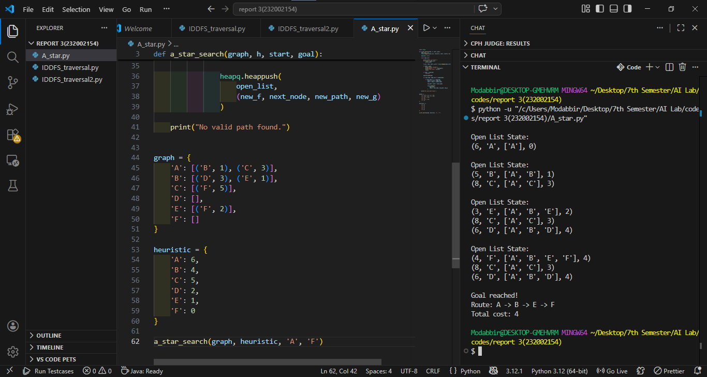

6. ANALYSIS AND DISCUSSION:
Both algorithms were implemented successfully and produced correct results. IDDFS found paths by increasing depth step by step, which is memory efficient but can be slower due to repeated exploration.
In contrast, A* performed faster by using heuristic values to guide the search and find the optimal path. Some challenges were faced with recursion in IDDFS and handling the priority queue in A*, but they were solved through debugging.
Overall, the lab helped in understanding the difference between uninformed and informed search, and all objectives were achieved.

